ON TIME PRODUCTION REPORT

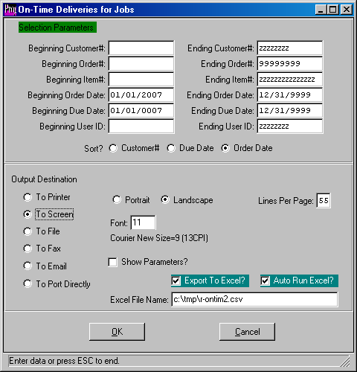

D-R-15 is a Production on time report

This report determines if the job was produced on time and does not consider time of shipment.
This report will print Order Date, Production Time = Due Date - Order Date.
This report will look at projected days to produce the jobs versus the actual receipt date as the production date. On time is fully received prior to due date. Thereafter the job is considered late. The report will search all orders and jobs, not dependant on if it is open or closed.
To determine if the item shipped on time, run the O-R-14 on time delivery report.
The report may be sent directly to excel.

